GRAFTED AVOCADO TREES
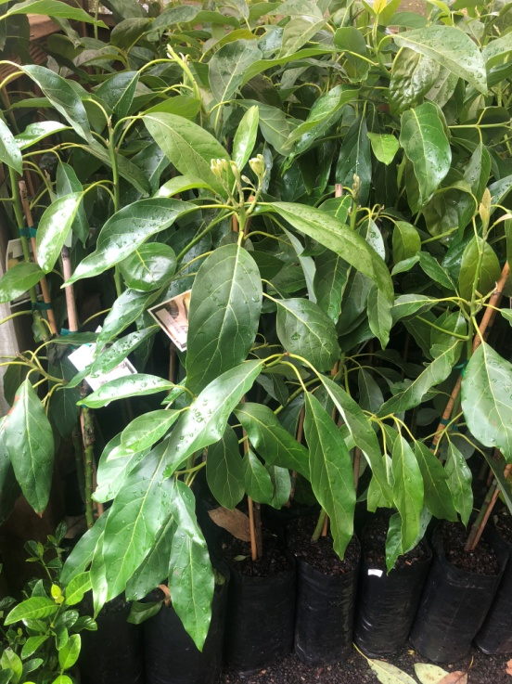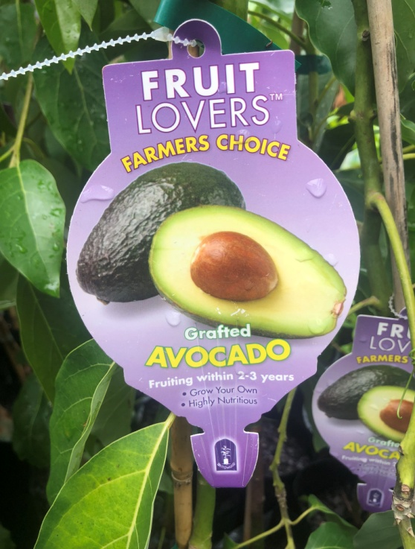
IN STOCK NOW
including
Hass (A)Is a large upright spreading tree tolerant of wind and cold, with a thick pebbly, purple coloured skin, fruit is oval shaped. The fruit texture is of excellent quality with an approximate weight of .28kg. It matures September – January when the skin turns purple-black.
Fuerte (B) Is a tree of spreading growth habit, with smooth green pear shaped fruit of magnificent quality. Fruit weight is approximately 1/3kg and matures June – October. It is the most widely planted of all varieties and is relatively frost tolerant.

Lamb Hass (A)
Larger and rounder than most other avocado varieties. It has a very dark, almost black skin that only gets darker as it ripens. The flesh is a pale green colour with a creamer consistency than its more common Hass relative and it has a slightly nutty and creamy taste. It has a medium-sized seed. Lamb Hass is a smaller tree that bears more fruit and it matures later in the season.

Pinkerton; (A) A rounded fruit with the later crop being more pear-shaped. The thick flesh has a smooth-texture, good flavour and high oil content. It shows some cold tolerance and bears consistently heavy crops. Harvest from June to August the fruit is medium sized with green leathery pliable skin and a small seed.
Wurtz; (A) Avocados are delicious! The flesh of the Wurtz avocado will not turn brown after it is cut, making it perfect for pre-prepared salads.
The Wurtz skin is generally rougher in texture and green in colour. It is available almost all year round, except for a small window in March.
The wurtz avocado will stay green when ripe – so to test for readiness, gently squeeze the neck, if it gives a little it is ready.

Avocados are easy to grow in Gippsland
We have 2 varieties growing in orchard at the nursery which have been in the ground for about 4 years and they had at least 15 frost on them last winter 2 -6 degrees that shows how hardy they are because they are looking great at the moment but you need to look after them for the first year or two but after that then they are trouble free, keep them well mulched (and planted on a mound) if you have clay soils and watered and protected from the hot summer sun and hot winds by using some shade cloth around the tree for the first 2 years, they are pest free and don’t need pruning. They are partially self fertile but will give large yields if a flower type A & B are planted. For more information ask at the nursery

Price grafted Avocados $68.00
ROWES NURSERY
105 Landsborough st
Warragul
56222223

