ROWES NURSERY
AUTUMN 2024 NEWSLETTER
PLANT OF THE MONTH
SALVIA HOT LIPS
DESCRIPTION: Salvia hot lips is an easy to grow perennial. Developing predominantly red and white flowers throughout the warmer months, but also during this period the plant may change colour to pure white or red. Salvia hot lips creates brilliant lasting colour over a long flowering period and is great for those sunny, drier positions.
POSTION; Prefers a sunny site in well drained soil. Most salvias tolerate dry spells and frost once established, Trim back in winter and mulch well. Full sun and well drained.
H 1m x W 1m IN STOCK NOW

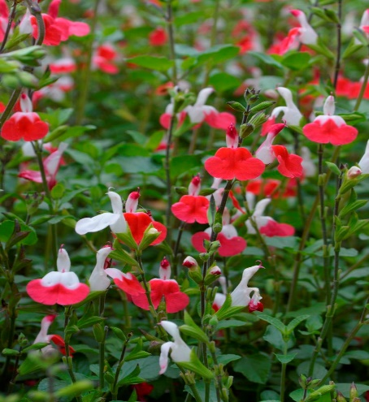
DESCRIPTION: SUNDAE FRAISE sun hardy and easy to grow.
Abundant flowers throughout summer and autumn.
Flowers begin white and mature through to a range plink and red.
Exceptionally, compact, and fast growing.
POSTION; Small spaces, patios, balconies, and entertainment areas or colour for small spaces to full sun locations IN STOCK NOW
IN STOCK NOW

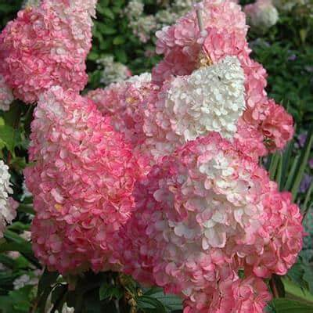
THINGS TO DO IN THE GARDEN NOW
Start to prepare your garden for autumn plantings, adding manure, compost, blood and bone or organic complete fertiliser to your garden beds. We stock sheep manure because it is suitable for vegetable gardens, ornamental gardens and gardens beds under trees. We have organic sheep manure available in 40 litre and 25 litre bags.
Easy to grow clump growing veggies and fruiting plants can be less work except for a bit of topdressing and occasional weeding and pruning these plants include Asparagus, Rhubarb, Strawberries, Artichoke, Jerusalem artichoke, Tree onions, scarlet runner bean, Fennel, Sweet potato, Gooseberry, Currants, Raspberries and Strawberries Grow them among other plants in the garden or in your regular veggie garden.
Revitalise your vegetable bed over winter sowing – Goodman’s Green Manure crops which will revitalise and open the soil, it adds Humus and Nitrogen to the soil, and help suppress weeds during winter. For best results the crops should be sown between March and July. The crop should be dug in about 1 month prior to planting vegetables.

Dead head summer blooming plants, a light prune is beneficial but do so in a spell of cooler weather to prevent foliage burn.
Want to have spring flowering bulbs this year, now is the time to prepare garden beds with compost and manure in preparation for Autumn sowing.
Are your geraniums or pelargoniums getting out of hand? They are best pruned. During March or April when you can prune back to one third their present size. You can propagate plants from the pruning’s.
TIME TO PLANT VEGIE SEEDS; Beetroot, Broccoli, Brussels Sprouts, Cabbage, Carrots, Chinese Cabbage, Leeks, Lettuce, Parsnip, Radish, Silverbeet, Spinach, Spring Onions, Swede, and Turnip and from SEEDLINGS Broccoli, Brussels Sprouts, Cabbage, Cauliflower, Leeks, Lettuce, Rhubarb, Shallots.
Use of raised veggie gardens raised beds are easy to construct on your own, making them from timber, bricks, concrete blocks, and old roofing iron are excellent options for many. and filled up with good soil and plenty of organic matter you can even make them into a no dig garden by using hay or straw on the bottom, then soil on the top. Ready-to-assemble and prefabricated kits are also available, anyone can now have a few raised beds to grow their veggies in their back yard.
Do you need to re mulch some areas? To mulch vegetable gardens, use sugar cane mulch, bark or wood chip mulch is better suited for ornamental gardens. Keep citrus and avocado trees well-watered, both should be fed well now as they are in a growth period. If you bought an avocado plant from us within the last 3 years, they need to be fed. Avocado and citrus trees require mulch around the tree to be about 20cm deep, but away from the trunk not piled against it, the mulch area should extend for 1-1.5 metres from the tree. We have 4 varieties of grafted Avocados in stock now
Time to place orders for Camellias now Camellias are popular and in stock now, used as a focal point in the garden or used as a hedge to cover up fences and sheds. There is a large range Camellias, Sasanqua and Japonica are very popular and easy to grow.
TREES IN STOCK NOW
Flame trees, Crepe myrtles and Magnolia little gem and more
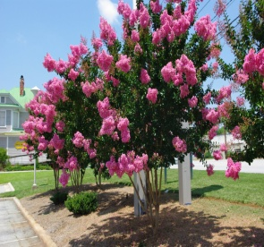
Description; Crepe Myrtle Lagerstroemia Indica’ are a favorite flowering ornamental tree coming in a range of flower colours and ‘varieties for sale in large medium and dwarf forms. Brilliant flowers, drought tolerant and with wonderful bark and with new cultivars and dwarf forms of crepe myrtle available for sale now. Crepe Myrtle are a great small tree for smaller gardens and are good also for containers, Crepe Myrtle deserve a position in the garden.

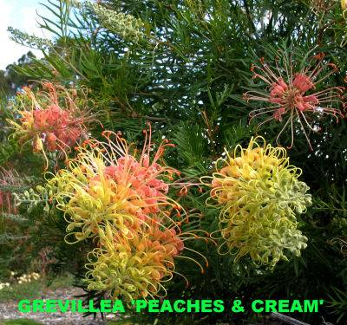
GREVILLEA PEACHES and CREAM Small naturally bushy shrub, Attractive green foliage, frost tolerant, cream flowers turning to peach in colour.
USES: Suitable for all size gardens, courtyards, waterwise gardens and feature plant.
IN STOCK NOW
Cauliflowers, Cabbage, Broccoli should be planted now from seedlings, for them to be ready for winter. We suggest that to protect these plants from moths, insects and birds, netting should be placed over these plantings. You could spray with Dispel which is an organic spray we have in stock to control Cabbage Moth grubs ?
Bird netting heavy duty, 10mtr wide will cut to the length that you need at the nursery
Hanging Baskets
Patios and outdoor areas can be enhanced by plants in hanging baskets, there are many plants suitable for growing in baskets, e.g. pansies, native ground covers; we have growing in baskets Dichondra Silverfalls,
ABOUT US

ROWES NURSERY is everything you would expect from a nursery but with a difference. We grow a large percentage of our own plants, passing on near wholesale prices direct to the public. Of course, we cannot grow everything ourselves so to make sure we have a large range we buy plants from other growers. You can browse through thousands of plants, perennials, shrubs, natives, ground covers, beautiful hanging baskets, hedge plants and much more+.
SEE US ON FACEBOOK
. ROWE NURSERY
105 Landsborough St
Warragul
56222223

